51
BATCHTOWN

HABITAT REHABILITATION AND ENHANCEMENT PROJECT

Pool 25
Upper Mississippi River Miles 242.5 – 246

Calhoun County, Illinois
St. Louis District

RESOURCE PROBLEM:

The Batchtown area was once a prime habitat site for large numbers of migrating waterfowl. Recently, the site’s habitat has been degraded due to siltation and inadequate water level control. By restricting sediment deposition and providing a means by which interior water levels could be varied for wildlife food production, the negative habitat impacts can be reversed to approach former conditions.
PROJECT FEATURES:

- Construct low-level levees to limit additional sediment deposition and allow for control of interior water levels;

- Install gravity drains; and

- Provide pumping facilities.

PROJECT OUTPUTS:

There is considerable interest to include an upland treatment program in this project. The construction of low-level levees and gravity drains will reduce the siltation rate, prevent river borne sediment from filling side channels, and provide water level management capability. The pumping facilities will ensure oxygenated water flow to improve spawning and overwintering fish habitat.
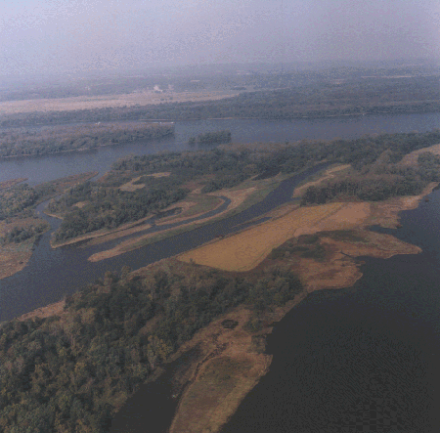
FINANCIAL DATA:

General design costs were $809,000, and construction costs are estimated at $7,100,000. Annual costs for operation, maintenance, and repair are estimated at $90,000 and will be the responsibility of the non-Federal sponsor, the Illinois Department of Natural Resources; and the U.S. Fish and Wildlife Service on Refuge lands.

STATUS:

The Definite Planning Report was approved by Headquarters, U.S. Army Corps of Engineers for ASA(Civil Works) in February 1997. A micro-model of this project is being prepared to verify sedimentation impacts of the recommended plan. The scheduled completion date is March 1998.

