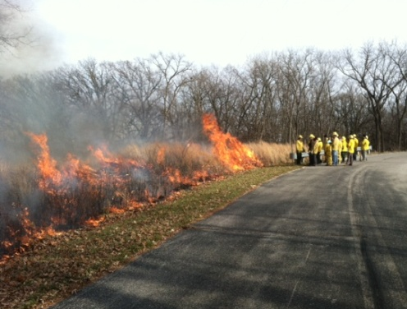
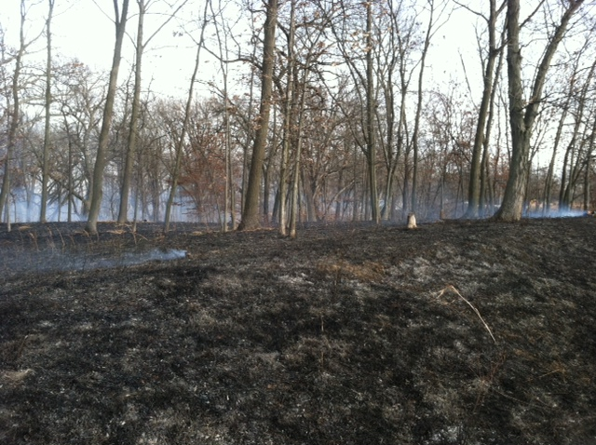
This fall a number of small timber burns were conducted around Saylorville Lake. These burns were executed by trained personnel to accomplish a number of set goals. Controlled burns in blocks of forested land can play a large role in helping the native ecosystem. These particular burns were conducted in order to maintain an oak savanna ecosystem by reducing woody understory vegetation and promoting desired grasses and forbs. Another important goal of these fires is to decrease the amount of fuel on the forest floor. Fuel is any leaf litter, down trees, fallen branches, or old stumps that pile up on the ground within the timber stand. An excessive amount of fuel can cause a large wildfire during certain weather conditions, creating a very dangerous situation for the many neighborhoods that are encroaching around Saylorville Lake. The Army Corps would rather burn these areas under controlled circumstances and proper weather in order to safely reduce the fuel and protect adjacent landowners.
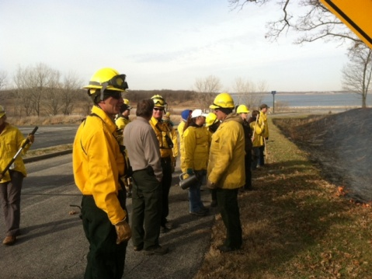
This year the Army Corps also partnered with a restoration class from Drake University to hold a “teaching burn” on public lands located near the dam. The group had received classroom instruction on controlled burning techniques and was anxious to demonstrate what they learned. With close supervision from the Army Corps Park Rangers and specialists from the IA DNR, the class successfully burned a 26 acre block of timber between the dam and Lakeview boat ramp. This was an excellent opportunity for the next generation of land managers to acquire some hands on experience.

